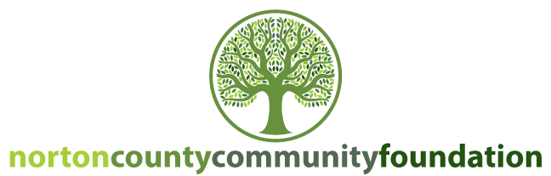

February 20, 2020
Dear Norton County Charitable Organizations:

The Norton County Community Foundation (NCCF) would like to invite you to participate in our third annual Norton County Match Day! This is a giving event designed to raise awareness and support for non-profits and charitable organizations in Norton County. Match Day 2020 will be held on Wednesday, July 22 from 7:00 AM – 7:00 PM in the Heaton Building in Norton, KS.

MatchDay 2020 is different from years past in that only organizations with an endowed fund at NCCF will qualify to participate. As a community foundation, we believe that endowments are a great tool to help nonprofits achieve long-term sustainability. If you don’t have an endowed fund with us, but are interested in learning more, contact us today! Organizations have until May 29, 2020 to establish an endowed fund at NCCF in order to qualify for MatchDay 2020.

NCCF has $20,000 that will be used to match the donations your organization receives between 7:00 AM and 7:00 PM on Wednesday, July 22. NCCF encourages local organizations to use MatchDay 2020 to promote new or existing programs, projects, or operating needs. Donations made to the organizations can be used for immediate needs or invested into the endowed fund. Matching dollars will go to the organization’s endowed fund held at NCCF.

Qualifying organizations are invited to set up a small table in the Heaton Building to help raise money for your organization. This is a great opportunity to talk with prospective donors about what your organization does, where their donation will go, etc. Each person who wishes to donate will have the option to donate to as many non-profits as they wish. At the end of the day, NCCF will calculate how much has been donated and then distribute the match money. The Norton County Community Foundation has committed $20,000 to this program. If $20,000 or less is cumulatively given, we will provide a dollar-for-dollar match. However, if total giving is more than $20,000, we will proportionately divide the funds based on how much was committed from the public. See the attached MatchDay 2020 Rules for specific guidelines.

If your non-profit or charitable organization is interested in participating in MatchDay 2020 please complete the enclosed form and return to the Norton County Community Foundation by Friday, June 5, 2020. If you have any questions, please do not hesitate to call or email the contact information below.

Thank you for all you do for Norton County and its citizens.

Tara Vance
Executive Director
Norton County Community Foundation
785.874.5106
tara@nortonccf.org

